**Day 35:**

DevOps : Development and Operation

Docker is an open source platform that helps to developer as well admin to build, package(jar or ware file) and run the application in light weighted and portable container environment.

Virtualization : VMWare software which help to run the virtual OS on base machine. Using virtualization we run or create abstract version of an OS.

Containerization : using containerization we can run abstract version of an application.

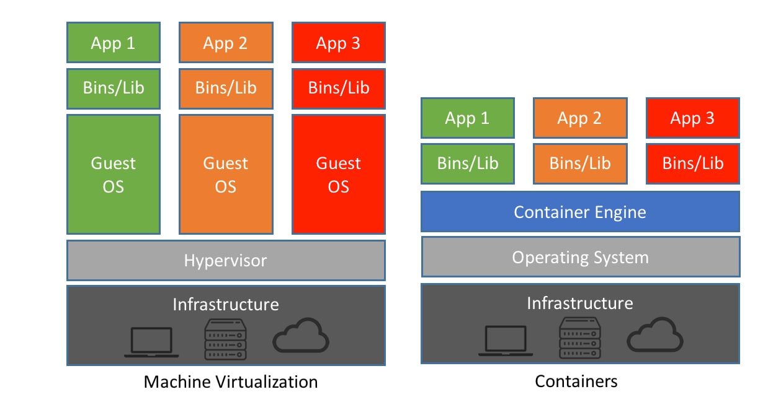

Container : A light weighted standalone and executable package that contains all the code and need external dependencies to run the application or software.

Docker Image: it is a ready only template file which is responsible to run the application with help of container.

Docker File: it is a text file which contains set of instruction to create the image.

Docker hub: It is like a git hub which help to push or publish as well as pull user defined as well as pre defined images.

Docker engine : it is an run time environment for Docker containers.

Create the Docker hub account and login through docker desktop

Open the command prompt

docker --version

docker info

docker images this command is use to display all images present in local machine.

docker pull imagename this command is use to pull the image

docker pull hello-world hello-world is one of the pre defined image. It pull in local machine.

To run the image

docker run imagename/imageId this command is use to run the image

**busybox : os image**

**creating custom**

1. Display simple welcome message using user defined images.